Nr. 577 **ANEXA Nr. 1**

[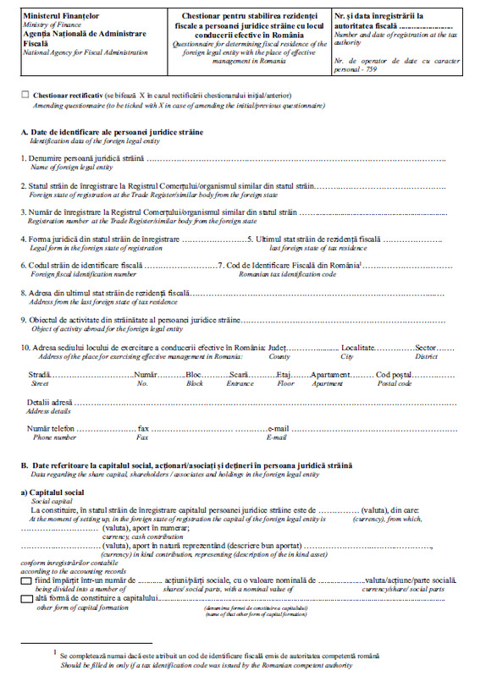](https://lege5.ro/Gratuit/g4ytmnbzgmzq/chestionar-ordin-577-2021?dp=gm4dcojzg44dgmy)

[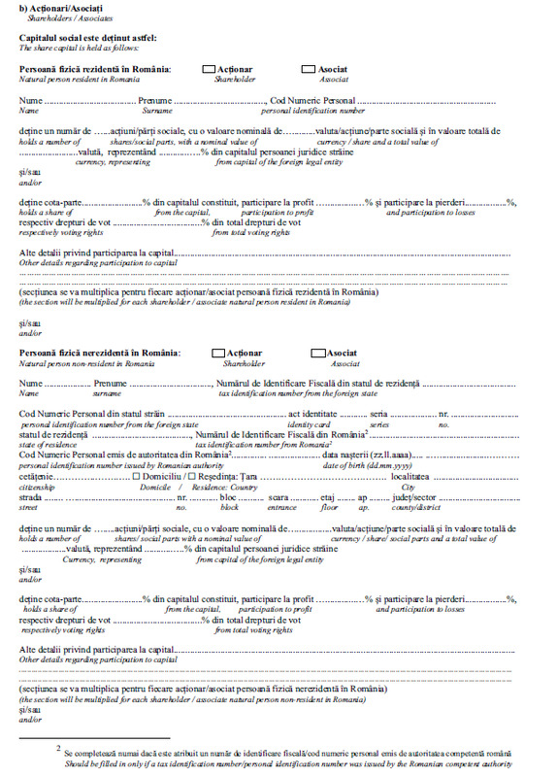](https://lege5.ro/Gratuit/g4ytmnbzgmzq/chestionar-ordin-577-2021?dp=gm4dcojzg44dgna)

[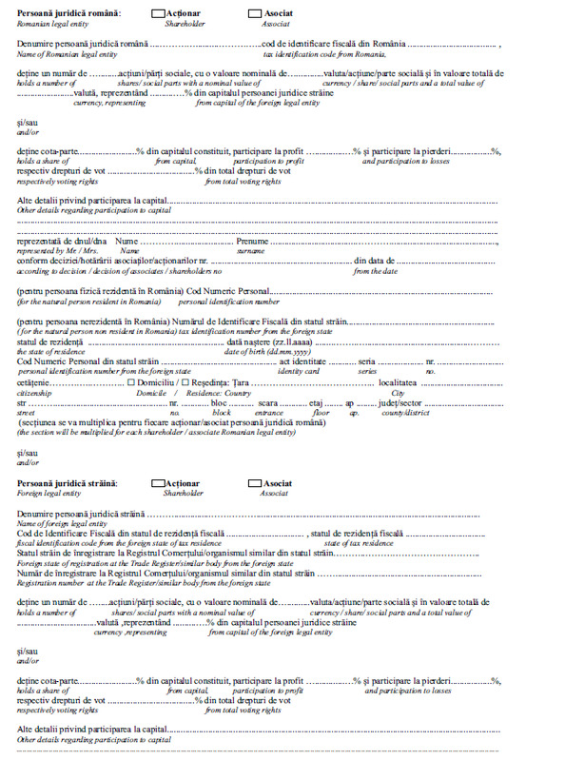](https://lege5.ro/Gratuit/g4ytmnbzgmzq/chestionar-ordin-577-2021?dp=gm4dcojzg44dgni)

[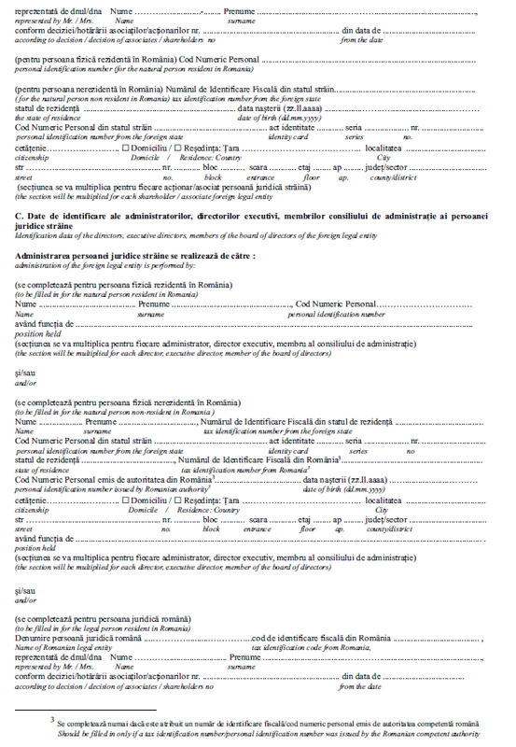](https://lege5.ro/Gratuit/g4ytmnbzgmzq/chestionar-ordin-577-2021?dp=gm4dcojzg44dgnq)

[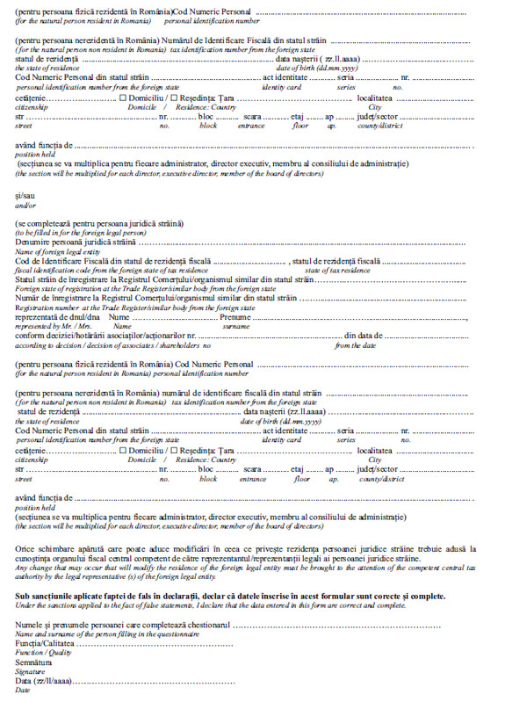](https://lege5.ro/Gratuit/g4ytmnbzgmzq/chestionar-ordin-577-2021?dp=gm4dcojzg44dgny)

[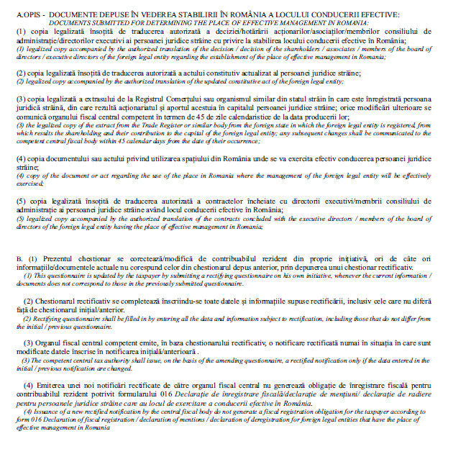](https://lege5.ro/Gratuit/g4ytmnbzgmzq/chestionar-ordin-577-2021?dp=gm4dcojzg44dgoa)

#### ANEXA Nr. 2

[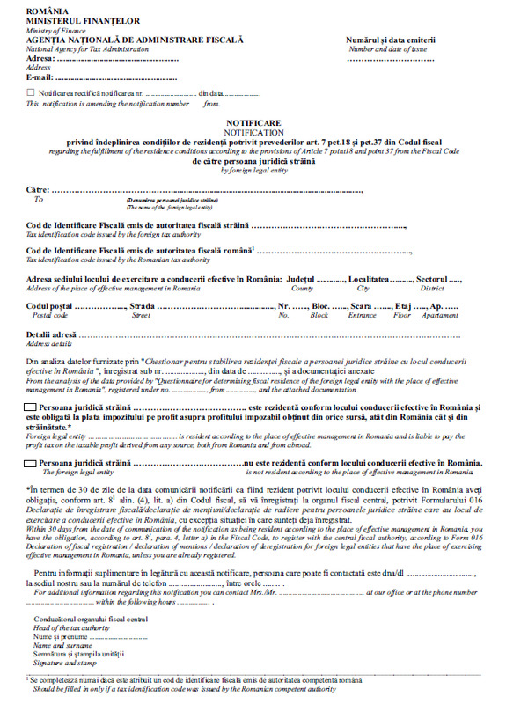](https://lege5.ro/Gratuit/g4ytmnbzgmzq/notificare-ordin-577-2021?dp=gm4dcojzg44dima)